|  |
| --- |
| Circle Language Spec |

## Relations

### Referrers

#### Concept

Objects contain references to other objects. At first, a referenced object is not aware of its referrers, but it is also an option for an object to register all its referrers in a list.

The referrers are not the parents containing the references to the object, but the referrers are the *references* to the object themselves.

When a related item is set to point to a certain object, the Related Item . Object . Set command will update the target’s list of Referrers. So the *referrers* update the target’s Referrers list. The referenced object does not update the Referrers list itself.

The Referrers list consists of references *back* to the referrers, but that does *not* mean the object in turn becomes a referrer of the referrer again.

An object can have a referrers list, but an object reference, so a related item or related list item (see the *System Objects* articles), can also have its own referrers list for references that refer to references.

##### Not Supporting the Referrers Concept

An object could choose not to support the Referrers concept, if the programmer knows, that this object will be referenced so many times, and there is so little interest in knowing all its referrers, that it would be ridiculous maintain a list.

But by default, the Referrers concept is always supported.

#### Diagram Notation

The referrers of an object are simply displayed as a sub-list called Referrers, every item of which points back to the references to the object:

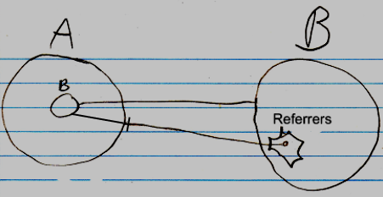

The entry in the Referrers list is pointing to a related item in the parent object A, not directly to an object.

The lines coming out of the referrers list are usually not shown, because a line tied *to* an object already *implies* a referrer. The diagrams will have more features later, and the referrer lines would obscure the picture.

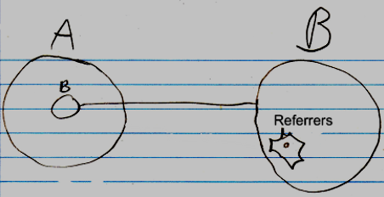

Even the whole referrers list may even be left out of the diagram by default, but it is not clear yet, if that is the way to go.

If something refers to a reference, then this may look like this in a diagram:

b in A is a reference to the reference to c inside B. To display the referrers in the diagram, you could <>do something like this<>:

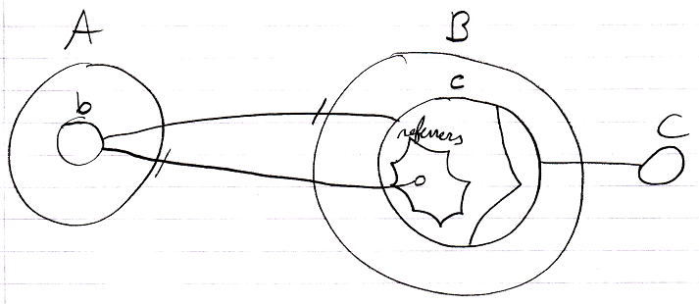

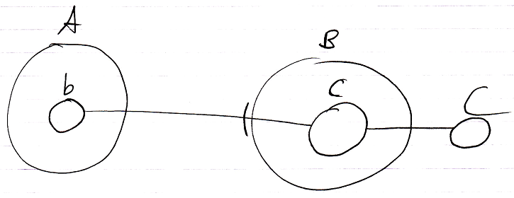

### Class Referrers

#### Concept

The *Referrers* article explained how an object can be made aware of its referrers. A *class* can also be made aware of the objects using it as a class.

Classes are implemented as a concept. That concept adds an object reference to the system interface. This object reference points which other object is its class. So oddly, an object reference, that points out the class, is already added to the class’s list of referrers. The classes are registered inside the same list of referrers as object referrers. This is actually just fine. The Referrers list is supposed to be a low-level view on the refererrers.

A class is usually only *used* as a class, and not also used as an object, so in practice, the Referrers list of a class, actually already *is* a list of class referrers. So a separate list of Class Referrers will not be implemented.

But if in the future there is a need to also maintain a separate list of class referrers, a separate Class Referrers concept could be implemented. In that case, when a related item’s *class* is set, the Related Item . Class . Set will update the target’s list of Class Referrers.

##### Not registering class referrers

The amount of referrers of a Number *object* may be small, but the amount of referrers of the Number *class* is humungous. The class will even have a Referrers list, when the class is not a created object, because Referrers applies to both symbols and objects.

You would want to turn the Referrers concept *off* for the Number class and *on* for Number objects. But the problem here is, that a class is a blueprint for an object. An object only supports Referrers, because the *class* supports it.

The first solution proposed was to simply not support the Referrers concept for classes that are widely used. But then for widely used classes, the Referrers concept never be supported. That is against the idea of supporting the Referrers concept by default.

If you can not stop a class from supporting Referrers without stopping objects from supporting Referrers at the same time, then the Referrers concept will not be widely used anymore.

Therefore, you are going to have to specify for a symbol or object, that it is a non-practitioner of a concept. Derivation of objects will take over the specified concept, but not the non-practitioner aspect. Or perhaps instead of calling it non-practitioner, you could call it Objects Support Concept Referrers, or something.

#### Diagram Notation

< The notation of a reference to an object reference’s class needs to be determined in the future. >

Because the concept of referrers simply also functions as the concept of class referrers, it can be displayed in a diagram the same way, except, that classes and class references are displayed with dashed lines.

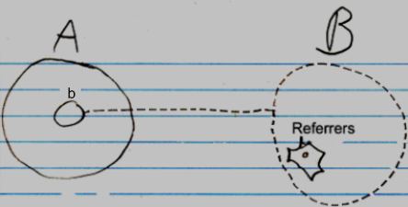

The reference line of the item in the Referrers list is displayed, then it has to point to the class redirection of symbol b. There is no final notation yet for a to something else’s class. But a preliminary notation could either be a reference to the Class inside b’s system interface:

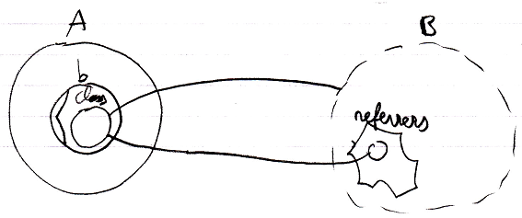

Or a reference line connnected to b’s class line:

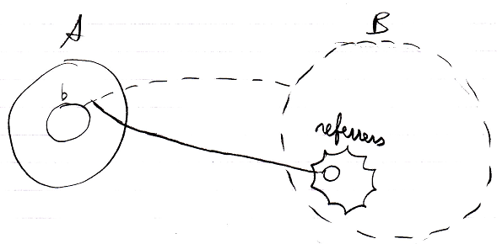

The referrers are pointed at by solid lines, because they are just references to the objects, that use it as a class. No implicit notation of making the referrer lines *dashed* will be used here, because that will introduce too much ambiguity in the diagram notaiton.

As mentioned in the article *Referrers*, it is not clear yet under which circumstances the whole referrers list might be completely left out of the diagram.

If a class defines that its objects support Referrers, but the class itself won’t register its Referrers, then the Referrers list of the class will be drawn out with dashed lines.

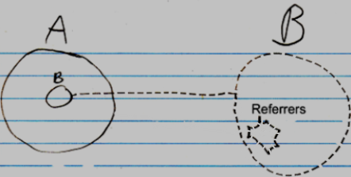

Obviously, the inactive referrers list will not contain any object references.

### Related Classes

#### Concept

Target classes specify sub-objects.

If a sub-object in a class also gets a class assigned to it, then this relates the target class to the target class of the sub-object. The target classes of the sub-objects are called the object’s *related classes*.

If a class does not fix the class of a related item, then any type of object could be assigned as the related item. If a class fixes the class of a related item, then the related item can only become an object of that class.

A class can also specify related *lists*. If a class is assigned to this related list, the related list can only contain items of this class. If no class is assigned to a related list, then the related list can contain objects of any class.

A related list can also be assigned *multiple* classes, meaning that items of a fixed set of classes can be put inside the related list.

In that case one related list creates two related classes.

If a class’s related item does not have a class, the related item does not introduce a new related *class*.

#### Diagram Notation

The concept of related classes is explained in the article *Related Classes*. This article only explains its expression in a diagram.

Below are displayed an object and its class. The class has two sub objects, each of which points to another class:

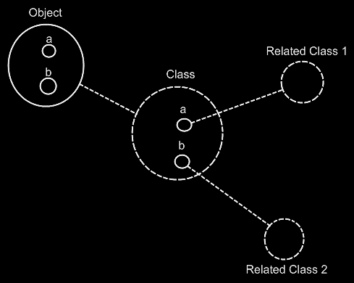

The Object automatically gets the same contents as the Class. The object’s sub-objects a and b could have been tied to Related Class 1 and Related Class 2, but they are not, because the sub-objects of Object and the sub-objects of Class are implicitly tied together by the tie between their parents Object and Class and the fact, that they have the same name, following the principle of *implicitly connected through parent* (will be explained in the article *Automatic Containment*).

For a big part it is true, that dashes uncover the structure of a system, while the solid lines uncover the system’s data. All the classes and their related classes and the lines between them are dashed. However, the sub-objects defined inside a class are not dashed, because they do not function as classes themselves. And also, the lines from object to their class are dashed. So it is not 100% true, that all the structure elements of the system are dashed, and all the data is drawn with a solid line, but it’s close to it.

When you want to see the structure of the system, and ignore the data of the system, you just have to look at the diagram from the following perspective: class structure = classes tied together.

The below is the same example, but now the classes get further redirected.

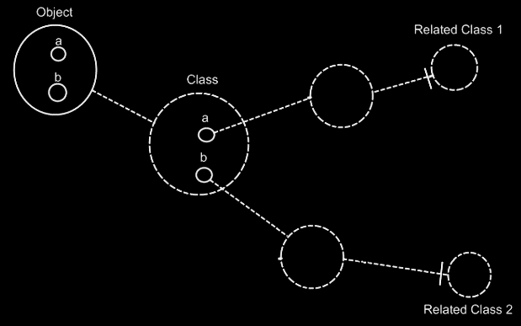

If the dashed lines do not emphasize the classes and relations enough, a coloring could be applied to the diagram, highlighting all the classes and their relations to other classes.

A class can also have a related list: a class holds a list of items of another class. A multiplicity of *many* is expressed in the diagram with a nonagon:



If the nonagon is placed inside a class, then the class specifies a list of items:

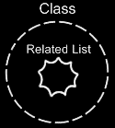

No class is assigned to the related list here, so the related list can contain objects of any class. If a class is assigned to this related list, the related list can only contain items of this class.

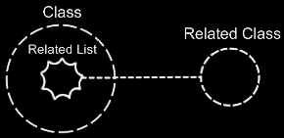

A related list can also be assigned *multiple* classes, meaning that items of a fixed set of classes can be put inside the related list.

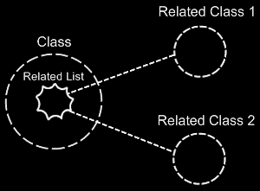

In that case one related list defines two related classes.

If a class’s related item does not have a class, the class has a related item, that can be od any arbitrary class. So this related *item* does not introduce a new related *class*.

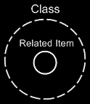

### Relations

#### Concept

One object can relate to other objects, but that’s not what we are usually speaking of when we talk about relations. When we talk about relations, we are talking about relations between *classes*. Relations between classes set the configuration of how objects can be connected to eachother. Classes and their relations determine the rules by which the objects behave.

The concept of *relations* is about thinking in relations between classes, rather than loosely tying together arbitrary objects.

A class functions as a blueprint for objects. The class structure determines which types of objects can be connected to eachother, but not yet what specific objects are connected to eachother. Which specific objects are connected to eachother is determined by the object structure. The class structure only defines which types of objects can be connected to eachother.

The class-relation structure is the bonestructure of a program.

The article *Related Classes* already explained how one class relates to other classes. But this is a very single-sided view on relations. It does not create a relation from the related class back to the first class again.

Relations are usually bi-directional. If one class relates to another, then the other class relates back to the first class. So next to one class getting a sub-object of another class, the other class also has to get a sub-object that points back to the first class.

You can also have a 1 🡪 n relation between two classes. In that case one class has a related list of items of another class. The other class has a single related item, that connects back to the first class. There are also n 🡪 n relations, where one class holds a related list of items of another class, and the other class also holds a list of related items, that connects back to the first class.

#### Diagram Notation

It must be mentioned, that the method of *automatic containment* applies to unary references, and just *does not match* yet with the notation for relations. In the future it must be further worked out how to best turn them into a single notation.

As explained in the article *Related Classes in a Diagram*, a relation

between one class and another can look like this:

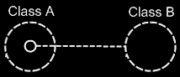

Because Class A has a sub-object of Class B, this creates a relation from Class A to Class B. However, Class B does not have a relation back to Class A yet. The picture below, adds the relation back to Class A:

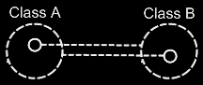

Because the class references back and forth are so closely related, the two class lines merge together to form the picture below:

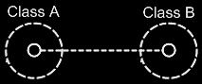

This, however, creates an ambiguity in the notation. The two circles tied together with a class line suggest, that they are both the same class. But the circle inside Class A represents Class B and the circle inside Class B represents Class A.

Fortunately, the notation can be disambiguated using the rules of automatic containment. Automatic containment is explained in the article *Automatic Containment*. Before explaining how automatic containment leads to the eventual notation, here is the disambiguated notation of a relation between two classes:

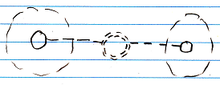

The notation is accomplished by first taking the original picture with one class refering to another and the other refering back to the first class:



Then, an imaginary reference to each class is added to the diagram

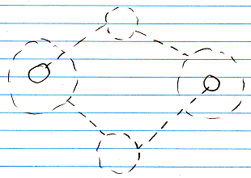

Next, the class lines are merged, but also the class symbols are merged:



The notation would still be ambiguous, if it weren’t for the double dashed line of the merged class symbols. So a double dashed circle symbolizes a relation between classes.

The picture above expresses a 1 🡪 1 relation between Class A and Class B. But other multiplicities can also be used. The multiplicity of n is expressed with a nonagon:



A nonagon represents a list of things. Instead of letting a Class A contain a single item of Class B, you can let is contain a list of items of Class B:

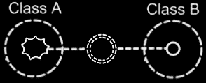

The picture above expresses an n 🡪 1 relation between Class A and Class B.

The picture below displays a 1 🡪 n relation between Class A and Class B.

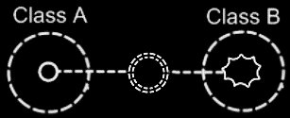

Finally, the picture below displays an n 🡪 n relation between Class A and Class B.

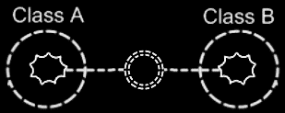

A symbol merge in a relation that has nonagons in it also results in a double dashed circle, because the imaginary reference to the classes, that are put on a higher level, are represented by circles, not a nonagons.

One related list can also contain items from multiple classes. Class A has a n 🡪 1 relation to items of Class B and Class C, it is expressed as follows:

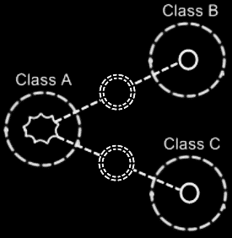

#### Class relating to itself

A class can have a relation to itself. For instance, a person can relate to a parent, which is also a person. So a person is related to a person, which relates a class to itself.

A class relating to itself looks as follows in a diagram:



#### Counterpart out of sight

When the counterpart of the relation is out of sight, a line should point out of the diagram. A catch there is, that you can’t see if the relation counterpart is part of a multiplicity of n or not. Therefore, the multiplicity is expressed at the end of th line pointing out of the diagram as follows:

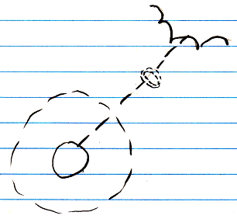

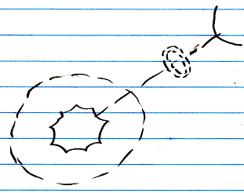

#### No reuse of merged imaginary references

If two imaginary references have merged, to become a relation symbol, then other references to the same classes won’t connect to an imaginary reference that has merged to become a relation symbol. Relations create their own imaginary references, that aren’t reused. This is displayed in the article *Relations Between Objects in a Diagram*, but may also apply to the notation of relations between classes.

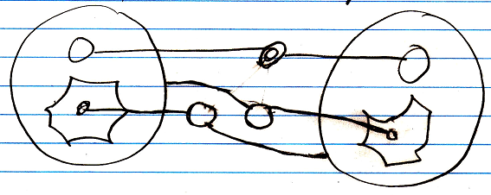

#### Example

Classes and their relations define the behavior of your system, so it is very important to be aware of them, instead of just looking at individual objects, tied to other objects.

The example below is part of the class-relation structure of a drawing program.

It displays the classes Application, Document, Point and Line.

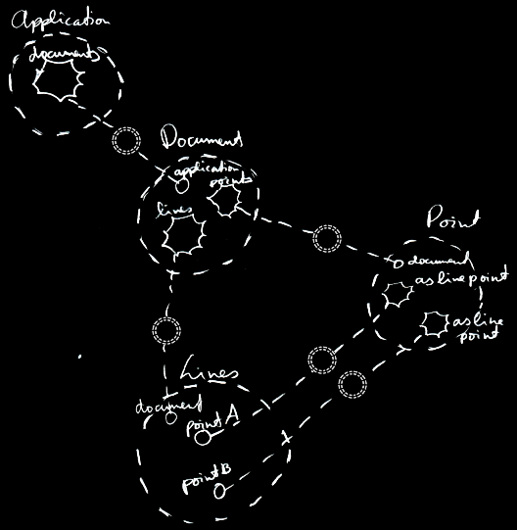

An instance of the application can hold multiple open documents. So Application has a 1 🡪 n relation with Document. That automatically makes a document part of one instance of the application. A document holds a collection of points and a collection of lines. That makes Document have a 1 🡪 n relation with Point and a 1 🡪 n relation with Line. This automatically makes Points and Lines part of a single document. Furthermore, a line is composed of two points. However, if you chain lines together, a point can become a part of multiple lines. This gives Line two 1 🡪 n relations with a Point: one for the first point and one for the second point.

The example displays all the classes, relations, related items and related lists of the object structure.

If just the use of dashed lines does not emphasize the classes and relations enough, a coloring could be applied to the diagram, highlighting all the classes and relations.

### Dual & Unary

#### Concept

A unary relation is a relation with only one direction: one class relates to another class, but the other class doesn’t relate back to the first class.

A dual relation is a bi-directional relation: one class relates to another class, and the other class relates back to the first class.

In most cases, it is best to make a relation dual. You don’t even have to give the the backward related item a name, just let it sit there, until you find a name for it.

Bi-directional relations were already introduced by the article *Relations*. What is left to cover is the reason why to make a relation dual or unary.

#### Ridiculous to maintain backward relation

Only if storage of a relation counterpart results in a ridiculous amount of data, that you don't even use, then you may want to omit the backward relation.

This is the case when the target class of the relation is very generally used. The key example for this is a *Number*. A number is used by too many other classes, so it is ridiculous to give a Number a related list for every class that uses Numbers. To determine if a backward relation is ridiculous to maintain you could also consider the following:

- No functional correspondence with anything particular

- Too many objects will refer to this.

This is all very subjective, but I can’t give a more exact definition for it.

#### Unable to program class

Another reason for not keeping the backward relation, is that you may not be able to program the target class, because somebody else authored it. But there’s a way to go around this: use inheritance to create a derived class, relate to the derived class, storing the backward relations inside the derived class. Then the original class is not burdoned with extra related lists. The derived class is an extension of the original class.

#### The Referrers Concept

A Number class could choose to support the Referrers concept. This will give a Number object only one list of all referrers, instead of a separate list for every class that uses Numbers. Numbers may be used by many classes, but an individual Number object, is never used much. It is not a lot of data to register inside an Number object, which objects refer to that particular Number.

But then the Number class will also register all its *class referrers*, which is undoable, because a humungous amount of objects refer to this class. But a solution for this was already proposed by the article *Class Referrers*. You can choose for a class to not register its class referrers, while objects do register their referrers.

#### No exact formula

I admit, that I would like to give an exact formula for when a backward relation should or should not be maintained. But for now, I can only give a functional description of when it is ridiculous to maintain a backward relation. A programmer is going to have to determine it, when a relation should be unary.

#### Diagram Notation

The concept of dual and unary is explained in the articles *Dual & Unary, Related Classes* and *Relations*.

The expression of dual and unary in a diagram has already been introduced in the articles *Related Classes in a Diagram* and *Relations in a Diagram*. This article only puts the diagram expressions of dual and unary next eachother for a comparison.

This is a unary relation between Class A and Class B:

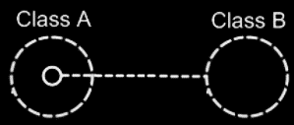

This is a dual relation between Class A and Class B:

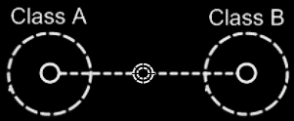

### Relations Between Objects

#### Concept

Relations between classes set the rules for how objects can be connected to eachother.

Relations between *objects* are the actual connections.

A relation between objects is always a relation between *two* individual objects. If one object refers to another, the other refers back to the first one.

From a 1 🡪 1 perspective this seems logical, but from an n 🡪 n perspective this may not seem logical.

A relation between two classes with each a multiplicity of n, creates a related list in both of the classes. Every object of those classes will contain a related list of related items.

Any object that as a relation to another object, gives the other object *one* relation back to the first object. So for each reference to an object, the other object contains a reference back. One reference inside an object is tied to one reference inside another object.

One object can relate to multiple objects, so an object *can* have a one-to-many relation to other objects, but one *related item* in one object always creates *one related item* inside the other object.

#### Diagram Notation

The concept of relations between objects is explained in the article *Relations Between Objects*. The current article only explains its expression in a diagram.

The main rule about relations to object is: for each reference to an object, the other object contains a reference back.

When you draw out the separate counterparts of a relation between two objects it looks like this:

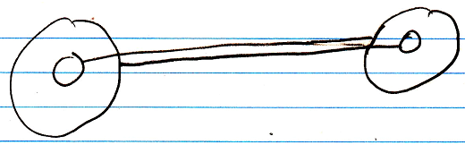

But to express the close relation between the two references, the two lines are merged, and disambiguated from normal object lines with a *relation symbol*:

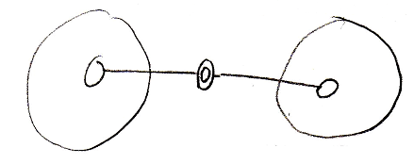

The relation symbol is a double circle. The reason behind this notation, was already explained in the article *Relations in a Diagram*. The notation is accomplished by first taking the original picture with one class refering to another and the other refering back to the first class:



Then, an imaginary reference to each class is added to the diagram

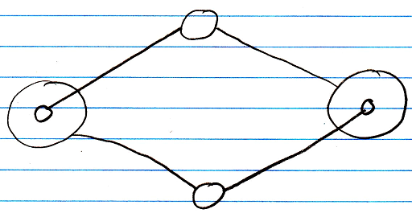

Next, the class lines are merged, but also the class symbols are merged:



The notation would still be ambiguous, if it weren’t for the double line of the merged object symbols. So a double circle symbolizes a relation between objects.

For relations between classes the relation symbol is a double *dashed* circle. For relations between objects, the relation symbol is a double circle drawn with *solid* lines.

In 1 🡪 n and n 🡪 n relations the rule, that each reference contains one reference back, also applies:

1 🡪 n:

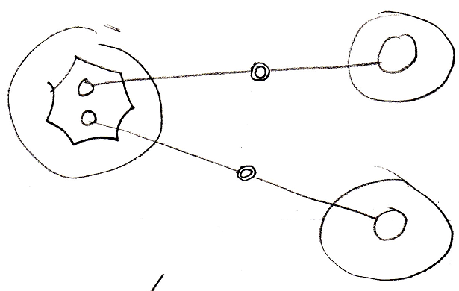

n 🡪 n:

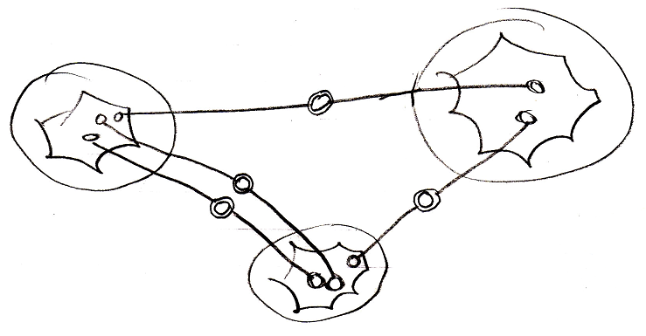

It doesn’t matter whether an object reference is part of a list or not: every time it is still *two* individual object references, that are tied together.

#### Object relating to itself

Sometimes an object relates to itself. In a diagram this looks as follows:

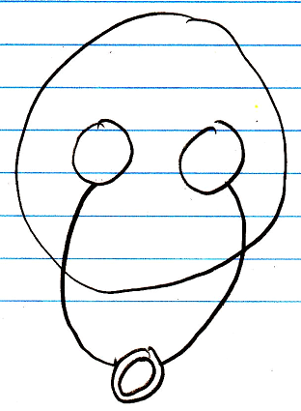

#### Counterpart out of sight

When the counterpart of the relation is out of sight, a line should point out of the diagram. A catch there is, that you can’t see if the relation counterpart is part of a multiplicity of n or not. Therefore, the multiplicity is expressed at the end of th line pointing out of the diagram as follows:

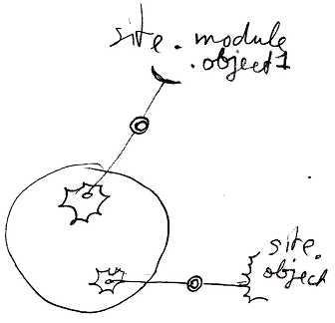

#### No reuse of merged imaginary references

If two imaginary references have merged, to become a relation symbol, then other references to the same objects won’t connect to an imaginary reference that has merged to become a relation symbol. Relations create their own imaginary references, that aren’t reused.

Here is a relation between two objects:



The two objects refer to eachother. This originally consisted of two distinct references:



Imaginary references were put on one level higher:



If other references to the same objects were also displayed in the diagram, then they would connect to the same imaginary references, put on a higher level:

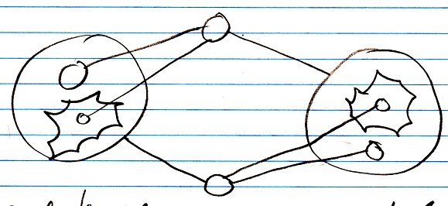

When you merge the imaginary references to display that two references are part of a single relation, you will not connect all

references to the merged imaginary reference:

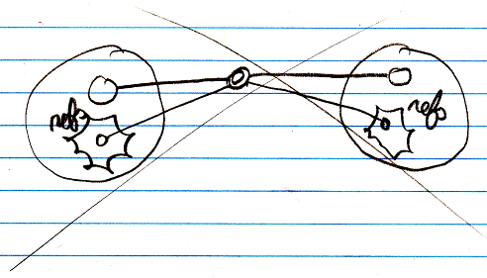

You will keep separate imaginary references for the other unary relations to the objects:



### Referrers Versus Related Objects

Referrers are handy, when so many classes relate to another class, that the other class does not want to maintain a separate list for each class that links to it.

It is also handy for when a class can't be aware of its related classes, so can not automatically get a relation back to classes, that want to link to it. In that case the other class can not establish a dual relation with the remote class, probably, because it does not have permission to alter the remote class. Or the remote class denies dual relationships to it altogether.

To make the remote class or object aware of its referrers anyway, you can let it support the referrers concept.

### Relation to a Pointer

#### Concept

As covered by the article *Related Classes*, you can also establish a unary relation with a *pointer* to another class. This is not so common, but it is possible all the same. This is mostly applied, to allow a class to make a sub-object’s class *adjustable*. It is important to consider, that everything inside a pointer is really part of the *target class*, but a pointer itself is usable individually, independent from the target class. This is well visualized in the article *Relation to a Pointer in a Diagram.* To make a relation to a pointer dual, you have to give the target class a relation back to the first class. The first class relates to the pointer, but the target class relates back to the first class. This automatically gives the pointer a relation back to the first class. This creates a dual relation between the first class and the pointer to a class, but only a unary backwards relation between the target class and the first class. This is because the first class does not directly refer to the target class, but the target class does directly refer back to it. You should see it in a diagram. That will make it much clearer.

#### Diagram Notation

You can also establish a unary relation with a *pointer* to another class. This is not so common, but it is possible all the same.

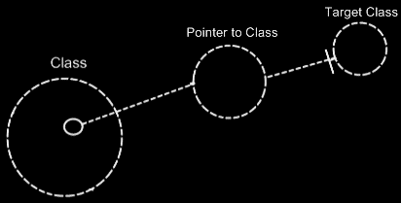

This is mostly applied, to allow a class to make a sub-object’s class *adjustable*.

It is important to consider, that everything inside a pointer is really part of the *target class*, but a pointer itself is usable individually, independent from the target class.

To make a relation to a pointer dual, you have to give the target class a relation back to the first class.

The relation back can be displayed in both symbols, that represent the target class:

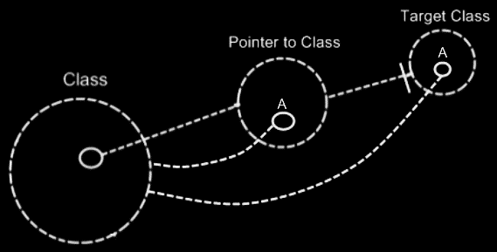

The two unary relations between Class and Pointer to Class melt together to a single dual relation. But the unary relation from the Target Class to the Class stays unary, because Class does not directly relate to Target Class:

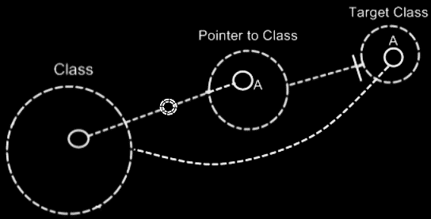

The notation for a dual relation was covered by the article *Relations in a Diagram*.

So only Class and Pointer to Class get a dual relation to eachother.

Target Class keeps a unary relation to Class. Funny enough, that unary relation is part of the dual relation between Class and Pointer to Class. The dual relation actually consists of:

- Class relates to Pointer to Class

- Target Class relates back to Class

The connection between Target Class and Class is already implied by the connection between Pointer to Class and Class. You’re allowed to leave out of the diagram then:

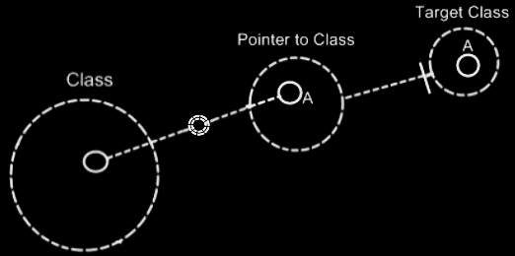

Target Class and Class are already implicitly related to eachother through the pointer to the target class.

In all the diagrams above, that display the backward relation, the sub-symbols of Pointer to Class and Target Class were given a name: A. This was done, because there was no line in the diagram to indicate that they were the same sub-object. Officially, when symbols share an aspect, in that they are equal in object, class, interface or definition, they should be tied together with a line. Officially an object line should have been connecting both symbols of A:

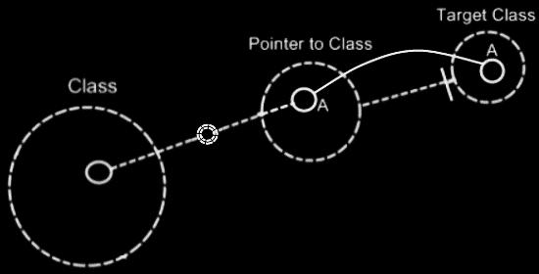

But similarity in aspect can also be implied by a *name* and the *connection between parents*. This kind of implicit connection is explained in the article *Automatic Containment*.

The only point to implicit connection through parent is to make the diagram clearer.

### Relation Synchronization

In a dual relation between classes, one class relates to another and the other class relates back to the first class.

But that is not enough to establish a full relation.

An object of one class can refer to an arbitrary object of another class, which then refers back to an arbitrary object of the first class again, but not necessarily the object we started with.

To see to it one object relating to another always makes the other object relate back to the first object again, you have to keep the two counterparts of the relation synchronized. When you make a change to a sub-object’s target, the other side of the relation also needs to be updated. This is called *relation synchronization*. Relation synchronization makes something between two objects melt together to one relation. Only when the two unary relations are synchronized, then it is a full dual relation between classes.

If two unary relations are not synchronized, then they are just two separate unary relations, that have nothing to do with eachother.

A complete dual relation consists of three parts:

- one class has a sub-object of another class

- the other class has a sub-object of the first class

- the two unary relations are synchronized

When you create a relation, you are adding those three elements. In the new computer language you are still able to create just a unary relation. In a programming environment you should be able to automatically turn a unary relation to a dual relation. In a programming environment you should be able to turn two already defined unary relations into a single dual relation.

Relation synchronization is not present in the class structure. Relation synchronization happens between *objects*.

As explained in the article *Relations Between Objects*, any object, that as a relation to another object, gives the other object one relation back to the first object. In other words: one reference inside an object is tied to one reference inside another object.

It doesn’t matter if any of the two object references resides in a list or not. When you let one of the object references link to another object, then the link from the old counterpart to the object should be broken and a link from the new counterpart to the object should be established. The object synchronizes the old counterpart *out*, and it synchronizes the new counterpart *in*.

Relation synchronization means ensuring the integrity between the two counterparts of a relation. When you assign a Lid to a Jar, the Jar is also assigned to the Lid. So whenever a Jar changes its Lid, the original Lid’s reference to the Jar is annulled, and the new Lid get a reference to its new Jar. This actually explains synchronization between 1 🡪 1 related objects. Synchronization happens when assigning a related item. When assigning a related item, the related item gets a reference back to the first item.

Relation synchronization happens when you assign a related object. When you assign Lid . Jar, then synchronizing the relationship, consists of, in turn, assigning Jar . Lid.

For every relation type it works in a different way.

There are three relation types:

1 🡨🡪 1

1 🡨🡪 n

n 🡨🡪 n

But synchronization is managed separately for each end of the relation, so synchronization is managed in the following four of ways:

1 🡪 1 synchronization

1 🡪 n synchronization

n 🡪 1 synchronization

n 🡪 n synchronization

#### Synchronization Types

There are four synchronization types:

1 🡪 1 synchronization

1 🡪 n synchronization

n 🡪 1 synchronization

n 🡪 n synchronization

Every synchronization type follows a slightly different procedure, to make sure that on assignment of one relation counterpart, the other relation counterpart goes along with it.

#### 1 🡪 1 Synchronization

1 🡪 1 synchronization is quite easy. In a Jar 🡪 Lid relation, when assigning Lid . Jar, The old Jar . Lid is set to Nothing, while the new Jar . Lid is set to This.

#### Risk of infinite loop 1 🡪 1

When a relation is synchronized, you may have a risk to an infinite loop.

When you assign Jar to Lid, then Lid is assigned to Jar, upon which Jar is assigned to Lid again, and so on. Fortunately, when a Jar is assigned a Lid it already has, the whole assignment is not executed. So it only goes as far as: Jar is assigned to Lid, upon which Lid is assigned to Jar again, upon which Jar is assigned to Lid again, but Jar already had that Lid, so that assignment is never executed.

#### 1 🡪 n Synchronization

In a 1 🡪 n relation between Parents and Children, every time you assign a Child to a Parent, Child . Parent is overwritten. The old Child is assigned Nothing as the Parent, and the new Child is assigned its new Parent.

Also, the original Child’s ID In Parent is yielded over to the new Child. The original Child’s ID In Parent is reset.

There used to be a misunderstanding, that one Parent could reference the same Child multiple times. But that idea was abolished, because when a Parent relates to a Child twice, the Child has to relate back to the Parent twice. A Child can only have one Parent, so it can never relate back to the same Parent twice. Something like that would require an n 🡪 n relation, for the Child to be able to hold multiple references to the same Parent.

#### Risk of infinite loop 1 🡪 n

Infinite loops for n 🡪 1 synchronization the are prevented the same way as for 1 🡪 1 synchronization. When you assign a Parent to a Child, The Child is added to the Parent, upon which the Parent is again assigned to the Child. But the Child already had that Parent, so the assignment is never executed. So that prevents an infinite loop there.

#### n 🡪 1 Synchronization

In a Child n 🡪 1 Parent relation, when you change Child . Parent, the Child is removed from its original Parent and added to the new Parent. So you can never have the same Child in several Parents.

A Child can not appear multiple times in the same Parent, because that, in turn, should give a Child multiple references back to the Parent, but a Child holds only one reference to a Parent.

#### Risk of infinite loop n 🡪 1

When a 1 🡪 n relation is synchronized, you may have a risk to an infinite loop. When you add a Child to a Parent, then the Parent is assigned to the Child, upon which the Child is added to the Parent *again*.

An earlier solution proposed for this, is that in synchronizing the relation, you never boldly Add the Child to the Parent, but you execute a Find Or Add, which prevents the Child from being added again, when it is already in the Parent’s list. This would have worked, but n 🡪 n synchronization already required a different solution, that will be more efficient for n 🡪 1 synchronization as well.

When you assign an item to a list for synchronization purposes, no synchronization is to be executed on the other side again.

You’d have to call a special List Item Set procedure, accessible only to the related class, that simply won’t synchonize back again.

#### n 🡪 n Synchronization

One *related item* in one object always creates *one related item* inside the other object.

Two items, related to eachother in an n 🡪 n relation, are always connected to eachother, by connecting two specific list positions to eachother.

In n 🡪 n synchronization, Object A’s reference to Object B will be replaced by a reference to Object C. When Object B is removed from Object A’s list, then Object A is also be removed from Object B’s list. After that, Object A is added to Object C’s list.

An item in one list is aware of its position in the other list. That makes it easy for an item in one list, to remove itself from the other list.

#### Risk of inifinite loop n 🡪 n

But when you add Object A to Object C’s list of related items, then Object C will try to add itself to Object A’s list of related items, upon which Object A will add itself to the list of Object C again. An infinite loop should be prevented here.

When synchronizing the relation between two objects in an n 🡪 n relation, you will add a position to the list of the referrer, and next assign an item to this position.

When you assign an item to a list for synchronization purposes, no synchronization is to be executed on the other side again.

You’d have to call a special List Item Set procedure, accessible only to the related class, that simply won’t synchonize back again.

Another solution opted at first, was to execute a Find Or Add for synchronization, instead of executing an normal Add command. That would prevent a related item from being added and added again. But then you have the problem: maybe the same item *should* be added twice to the list, because one item can relate to another item multiple times, which also requires the other item to relate back to the first item multiple times. For each reference to an item, the item must have a reference back to the referrer.

So the new option is better: you have a special List Item Set procedure, possibly called by a special Add procedure, used solely for relation synchronization, that won’t synchronize *back* again.

#### The abolished multiplicity of x

Earlier I had invented a multiplicity of x, which is plural, but then a fixed set of items, for instance three items. But x can be replaced by three separate 🡪 1 relations. X was abolished in particular, because it would cause a lot of unpredictable behavior when trying to synchronize the two relation counterparts, especially in n/x 🡪 n/x synchronization.

#### Confusions about relation sychronization

There used to be two points at which there was confusion about the workings of relation synchronization.

##### Confusion 1

What can be confusing is that, when a 1 🡪 n relation is synchronized, it can never be used as an n 🡪 n relation. In the relation Parent 1 🡪 n Child, every time you add a Child to a Parent, Child . Parent is overwritten. When you change Child  .  Parent, the Child is removed from its original Parent and added to the new Parent. So you can never have the same Child in several Parents. If you want to use multiple Parents, you can’t.

It is often easier to define something in 1 🡪 n relations, without thinking about it, that the backward relation might be 🡪 n too. But when a relation is synchronized, the system falls apart when a 1 🡪 n is actually intended as n 🡪 n and you’re trying to *use* it that way.

This can be misconceived as an error in the new computer language, or an inability of it, while it’s really just a wrongly defined relation.

So then it becomes really important to define the exact relation type of something, even when it’s more difficult.

If you do want to use the 1 🡪 n relation as an n 🡪 n relation, you should change the relation type, but you could also choose to split the dual relation into two unsynchronized unary relations. However, you will be loosing out on functionality and loosing integrity and coherence of the system.

A system in which all relations are dual and given the correct relation type, functions in perfect harmony and everything is logical, correct and solid.

##### Confusion 2

Synchronization could cause confusion in older versions of the computer language, where you have two dual relations to the same class, that are given the same Item Object Name. In that case, one relation’s counterpart synchronizing back to the related object could affect the other relation. By default it is not allowed to have one class A being 1 🡪 related to multiple classes, in which A has the same Item Object Name. That is only allowed if the other relations are made unary, and not dual, or if *melding* is enabled. *Melding* is a topic, which makes it possible for multiple relation classes or for instance *progressed objects (*article *Progression)*, to be referenced as a single related item, but it has to be stated explicitly that this is the intention. See the article *Melding*.

#### Diagram Notation

There isn’t really a display of relation synchronization in a diagram. You just know, that when a dual relation is expressed, the relation will be synchronized.

The procedures of relation synchronization are part of the system interface of symbols. System interfaces are the inner workings of symbols. The procedures of relation synchronization can be expressed in the diagram, if the system interfaces of the symbols are displayed. See the article *System Interface*.

This article shows diagrams to demonstrates the difference between *not* synchronizing two unary relations and *synchronizing* two unary relations.

Two unary relations will not be synchronized to eachother. An object of Class A can refer to an arbitrary object of Class B, which refers to an arbitrary object of Class A again.

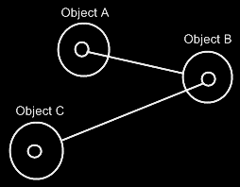

It doesn’t make the two objects refer to eachother. It just makes the two objects refer to an arbitrary object of the other class, but not necessarily to eachother.

For this, relation synchronization is applied, so that the first object and the second object always refer to eachother.

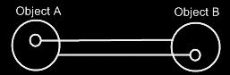

When the two following unary relations are synchronized,



then the two class lines merge together, to form the picture below:



Relations between individual objects also turn from this:



Into this:



### Relation Direction

When all relations are bidirectional, a side-effect might be that everything might end up at the same level hierarchically, since all the relationships are mutual.

That might bump with the containment structures that might look nice in Circle notation.

A proposed solution might be to specify a direction to these relations, so that the 'inferior' part of the relationship might be put at a lower level of containment, restoring the use of a containment structure. Perhaps a 1 to n relations might already imply direction: parent on top, children below.

This may only be a problem, if the containment structure would have to be figured out by the system on its own.

Another solution might be that a programmer can pick the containment level, so then maybe it is not really a problem and relation direction would be implied by the containment levels picked by a programmer.

## Loose Ideas

### Loose Ideas about Referrers

Taken out of the Referrers article:

<Compared to giving a number class a related list for every class that uses integers>

A number class could, however, choose to support a single list of all referrers. Then a number object will have only one related list. Numbers may be used by many classes, but an individual number object, is never used much. It is not a lot of data to register inside an integer object, which objects refer to that particular number.

JJ

Referrers,

2008-08-10

The Referrers concept needs to be redone.

Consider the system interface and make sure

you can register referrers in a reference,

as well as referrers to an object,

and consider whether you want the referrers

list to point to references or the the parents of the references.

The article Referrers in a Diagram, Class Referrers in a Diagramand Command Definition Referrers in a Diagram are involved.

I was looking at the Refferes diagrams. It’s not correct. The referrers list registers the parents of the references. I’m thinking now: they should register the references themselves. I must have been that I was unaware of the workings of the system interface back then…

JJ

Referrers,

2008-08-28

Referrers has to be redone. It has to become a list of related items and related list items, that they are inside their parents.

Redoing Referrers was postponed in the project Work Out Basic Command Articles, because it involves too much other material, that takes too much time to go into.

Referrers is mainly part of Relations.

You are probably going to have to read over the whole Relations article group.

The following articles may have to be redone, when redoing Referrers:

- Referrers

- Referrers in a Diagram

- Class Referrers

- Class Referrers in a Diagram

- Referrers Versus Related Objects

- Command Object Referrers

- Command Object Referrers in a Diagram

- Command Definition Referrers

- Command Definition Referrers in a Diagram

JJ

Referrers,

2008-08-28

The referrers articles are not finished, because referrers needs to be reconsidered later, and it involves much different material, that takes time to go into.

- I hate it, that I could not finish the referrers articles.

- But it is too much to go into just like that.

- I have to accept that the produced article group will contaiin two subjects, that are not finished.

JJ

### Loose Ideas about the Relations Section

#### ± 2004

The main unit in a relational structure is the *class*. There is a list of *classes*.

The classes are tied together with *relations*. One class is tied to another.

The main object that defines a relational structure is the Structure object. The Structure object contains a Classes collection and a Relations collection. If you want to add a class, you do that in the Classes collection. If you want to add a relation, you do that in the Relations collection.

The Classes collection contains objects of class Class.

The Relations collection contains objects of class Relation.

Every Class has an Attributes collection. A Person Class, for instance, could have a Name Attribute and an EmailAddress Attribute and more attributes such as Street, HouseNumber, ZipCode, etcetera. A Class also contains a RelatedClasses collection, which reflects all of the class’s related classes. You can’t add RelatedClasses to this collection. You have to define relations in the Structure.Relations collection and they will be *reflected* in the Class.RelatedClasses collection. Other members of the Class class are explained in other sections, covering different concepts. However, all members are briefly explained in a sub section below.

A **Relation** consists of two **RelationClasses**. It contains two **RelationClass** objects that define the two classes of the relation and how they relate to one another.

A **Relation** also defines whether the relation is **Dual** or **Unary**, by the **Boolean** **Dual** member. If a **Relation** is **Dual**, then both classes are aware of eachother and refer to one another. If a **Relation** is **Unary** then only **RelationClassA** is aware of **RelationClassB** and refers to it, but **RelationClassB** is unaware of **RelationClassA** and doesn’t refer to it.

Even though a **Dual** relation would seem to make **RelationClassA** and **RelationClassB** equal opponents, **RelationClassB** in many cases is the inferior one. For instance, in writing XML files, **RelationClassB** is seen as contained in **RelationClassA** and not the other way around. In that case *direction* of the relation does matter. However, still in many cases **RelationClassA** and **RelationClassB** are technically equal opponents. When you keep in mind which **RelationClass** is inferior and which one is superior, things like XML writing go well automatically. If you are sloppy with choosing if something is **RelationClassA** or **RelationClassB**, you could get trouble that makes you obliged to switch the two relation classes within the relation, but usually you won’t notice anything going wrong. So relax, but beware.

The two **RelationClass** objects define the relation furtherly.

The member **Class** of **RelationClass** is very important to set, and it defines which class makes part of the relation. Define the **Class** in both **RelationClasses** of the **Relation** and you’ve made a relation between the two classes.

A very important member of a **RelationClass** is the **AbstractNumber**. This defines whether a relation class is **1**, **x** or **n**. If you define the **AbstractNumber** for both of the two relation classes, you can for instance make a 1🡨🡪n relation between the two classes or a x🡨🡪n relation or whatever. **AbstractNumber** is **1** by default.

To define the quantity of x, you set **ExactNumber**. For instance, in a   
**Line n🡨🡪2 Point** relation, you define for the **Point** **RelationClass** that its **AbstractNumber = x** and its **ExactNumber = 2**.

Two other important members of a **RelationClass** are **CreateObjects** and **EnsureSubObjects**. **CreateObjects** is by default **True**, exceptions not regarded. **CreateObjects** says that when a new position is created within the related list, an object is instantly *created* in that position (See *Objects and Object Positions*). In many cases you want that to happen. Sometimes you don’t want objects to be created, because you’d want to assign an object to that position yourself. Then you set **CreateObjects** to **False**. Furtherly, **EnsureObjects** will see to it that you can’t assign **Nothing** to the object position. It is **True** by default, but can be set to **False**. For more information see the sections *Create Objects* and *Ensure Objects*.

And then there’s another member of **RelationClass** that is important to mention. And that is **ListType**. **ListType** is usually set to **NormalListType**, but can also be set to **ReferenceCountedListType**, **RegistrationListType**, **SharedListType** or **SelectionListType**. The list then gets very special behavior. For more information see the *Specialized Lists* section. Although I don’t explain them here very thoroughly, **ListType** does mean a lot for the general structure of the system.

You can see that inside a **RelationClass** object, much more is defined than just the **Class**. That’s why **RelationClass** is a separate class. Many times I will speak of a relation class, and you shouldn’t confuse it with just a class then, because it will be defining a class as it is in the context of a relation.

The elements as I’ve described them in this section, form the following structure of Classes, Attributes and Relations.

Structure

|

|-- Classes

| |

| |-- Class ()

| |

| |-- Attributes

| | |

| | |-- Attribute ()

| |

| |-- RelatedClasses

| |

| |-- RelationClass ()

|

|-- Relations

|

|-- Relation ()

|

|-- Dual

|

|-- RelationClassA and RelationClassB

|

|-- Class

|-- AbstractNumber

|-- ExactNumber

|-- CreateObjects

|-- EnsureObjects

|-- ListType

Every other concept of J Data is hung up on this main structure of **Classes**, **Attributes** and **Relations**.

For instace, the physical appearance in the user interface of a list defined in a **RelationClass** with **AbstractNumber = n**, is defined inside that **RelationClass** object. The whole appearance of a **List Control** is defined inside a **RelationClass**. That is an example of how the user interface is defined right inside the general structure above. The same way *all* of the application’s features are defined in the context of the relational structure of **Classes**, **Attributes** and **Relations**.

### Loose Ideas about Dual & Unary

Relations,

New thing: what I should consider in the future, is that a relation counterpart can be completely derived from the other relation counterpart. Therefore, you might make a relation dual, so the counterpart usable, but not STORE it, but derived it somehow. That way you can use all relation counterparts, just not store the ridiculously large ones. > No, because then you’d have to scan the whole internet for referrers.

JJ

### Loose Ideas about Relation to a Pointer

Relations,

Relations to Pointers,

2008-09-25

Pointers (references to related objects)

A relation between a *pointer to an object* and a *command*. The pointer is a totally different entity, than the object itself.

> 2008-10-01 I’d think, that this will add related objects to the system interface, so related objects to a related item system object, instead of related objects to the target object of the related item system object.  
This is a relations issue: relations to pointers in particuler.

I will need to look at *System Objects* to see what a pointer actually was: it was a relation to a related item, instead of a relation to an object independent of any other container.

JJ

### Loose Ideas about Relations in General

*The texts below are loose ideas yet to be turned into good documentation.*

References,

2008-11-05

It is important to exactly see

which objects can be accessed through an object.

You should see access connectors for them.

It is also very important that you can exactly see

which object access something.

You have too much the ability to not register

which objects actually access something.

Perhaps in practice it is not so bad to impose registering

dependencies always. Perhaps practically the consequences

are overviewable.

The negatives about not seeing ALL referrers, but only some,

or optionally are BAD. Because not seeing the connections between

all things create a lot of problems in software systems today.

Perhaps most problems with software systems today have to do

with not knowing what exactly makes use of what.

But how about commonly used classes, such as integer.

Integer objects all around can store a link to the integer class

on the computer language site. But the integer class

on the computer language site can not register all objects

around the globe of class integer.

Or perhaps consequences of many many references to the same

class can be MADE overviewable.

Perhaps you can make intermediate references to class integer

on your local site or local module. Then the references to class integer

on that site, reference the local reference to class integer.

The references to class integer on a site are registered in

the local site's shadow of class integer.

And in class integer on the computer language site only the shadow

itself is registeren.

Perhaps you can enforce such a pattern.

It is always a problem with classes widely used.

Any class could potentially be widely used.

You could set reference quota, though, to protect your site.

But class integer should be used billions and billions of times.

Perhaps to protect your site, you make a reference quata,

or you enforce shadowing.

In a shadow situation, I'd like to also see how many referrers

a shadow of class integer has. But you can do that.

Site computer language has class integer, which registers all

sites using class integer, and those registrations consist of

the registration of a shadow reference of class integer,

and the shadow reference of class integer returns the references

of the shadow again, but those references are stored on the

client site, not on the computer language site.

You still register all integers, but the registration is spread over

multiple sites, so the costs are spread and everybody pays

a reasonable amount of storage cost.

But could this pattern be misused?

What if a new internet protocol allows many many more sites,

and somebody thinks it is cool to create 1,000,000 virtual sites,

for some purpose and each site shadows class integer.

Then you have 1,000,000 more registrations in class integer.

That's where quota's come in.

But that can also be abused. An attack could use up the quota,

and new shadows to integer can not be made anymore.

Existing sites, that use class integer still work,

but nobody can program a new site of class integer then.

But there is a difference between in good practice, and in bad practice.

You have to ask yourself: how can we make it practically work when we

are all behaving ourselves. Some things do not work practically even if

we do behave ourselves. That's one area of problems to work on.

It is another area of problems where well behaved practice works,

but bad behavior overthrows the system.

That last part we call attacks, virusses, threats, etcetera.

That area of problems should be adressed differently.

It is a principle, that good practice should be facilitated,

and bad behavior should not compromise how clear you can

organize your system, so should not compromise your freedom.

Bad behavior should be adressed separately in the background.

Enough for now.

JJ

Taken out of Interfaces Articles on 2010-05-07:

Preventing class’s extension with commands:

A class can prevent itself from getting further extended with commands.

For instance, you don’t want the class Integer to be extended with any command that uses an integer. It is a question of it being rediculous to maintain a list of all commands that uses integers. Don’t prevent a class from being extended with commands, just because you think it makes your interfaces more reliable. Class Integer can also just make it a *default*, that it doesn’t get further extended with commands. Some commands that use Integer, you might indeed want to see added to class integer, but you need to actively choose that then. If parameters don’t extend a class with a commands, these parameters are only shown as parameters, and not as commands inside a class definition.

> 2008-09-06 This is actually a non-dual relation.

This is basically the same issue as covered in the section Dual & Unary, which explains, when it is rediculous to maintain a backward relationship. For instance: relationships from class Integer back to any class, that uses an integer are rediculous to maintain as well.

And if changes to the class are ventilated to all the objects this happens with the help of events, but usually you’ll just use versioning to use an unchanging production version of a class.

a class can *access control* the fact whether dual relations can be established to it.

I think, that a dual relation has a source site. One end of the relation has authored the relation, the other relation just complied.

Actually, this could happen dually.

JJ

Backwards relation alternative: Site usage

2010-05-03

For ‘ridiculous to maintain’ you could also go with this approach: make the small thing, like Integer always referenced in a qualified way through the site and maintain a unique list of source sites. That would at least give you an idea of how many sites are used and if any sites still use it.

JJ